**Larvel changes**

**I created a software using Neonlms template for laravel and I made many changes of it. The goal of software is make a checkup for company, so there are some checkups, argument and questionnaire.**

**The changes to do regard the survey builder (question page) bacause have banal code errors and design errors.**

**All change regard the front end and the back end, so every changes in admin must show the result in user pages. The changes are banal but I wrote a detailed document with all, so you can do without doubts.**

1.1 **Template of question**

It is necessary create a default informations (regard text and colors). So it is necessary add these default options inside the page “TEST”.

By next image you see how must be the future Test page

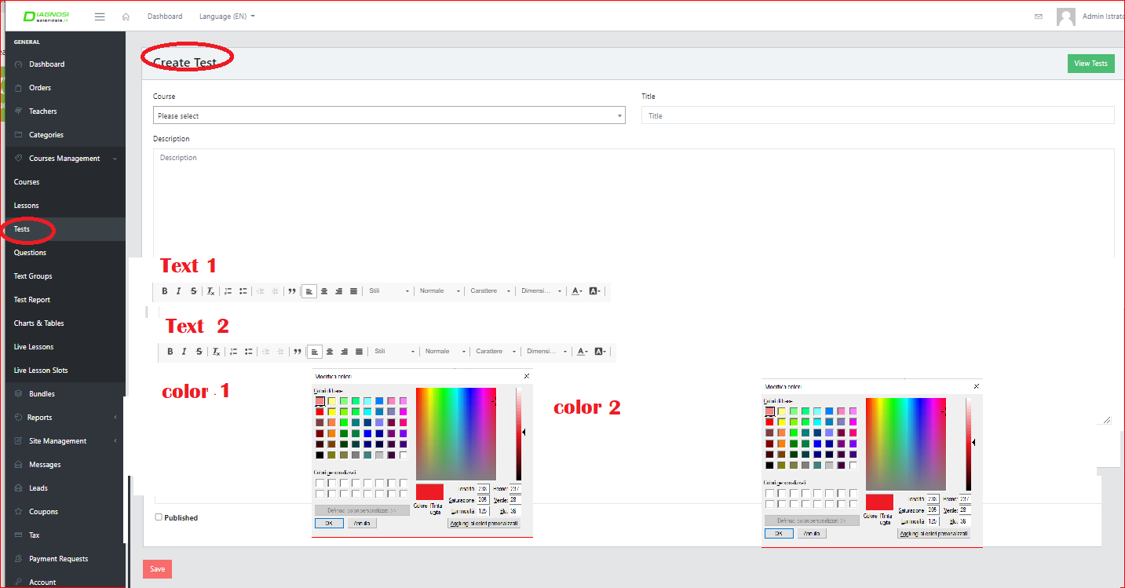

Obviously for a specific questions the administrator must do some changes regard the text of description, the help and the answers. And can make also change of colors of a specific answer. So the default option must be connected to the Questions Page that must have the options to change the default options.

By following image see the actual area of questions

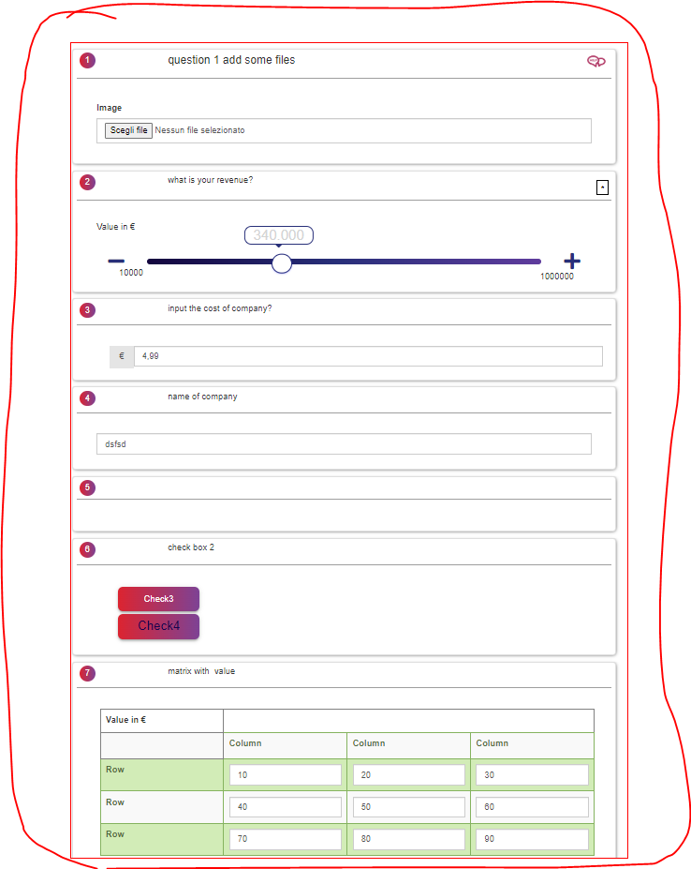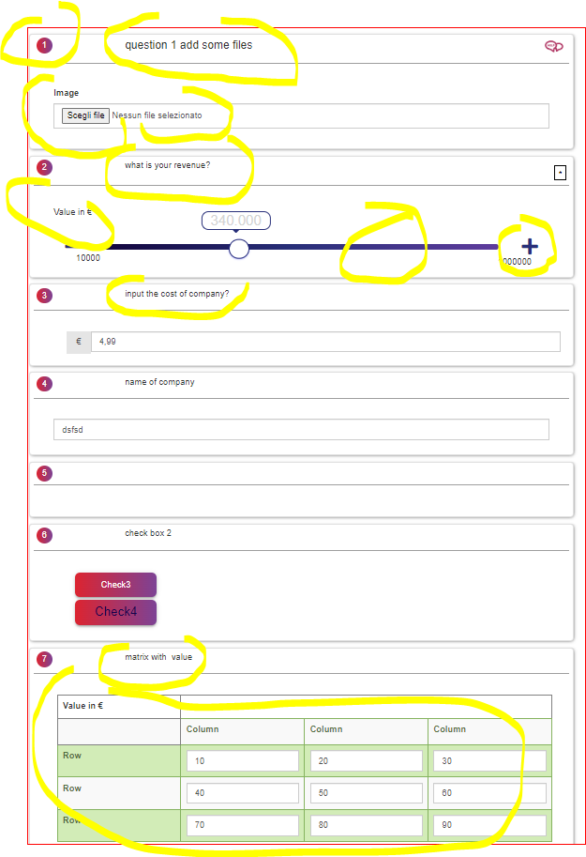

you see many confusions regard colors and texts (description answer and colors)

Example: if for example the administrator select grey color and arial 10 size. This means that all questions of thet test, (for example test b-course organizzation) must have how default that colors and text. The administrator when create question or change it, he can chnage the deafult informations.

Now by question description and help box it is possible change the text option, but it is necessary that these must have the default decided by test options

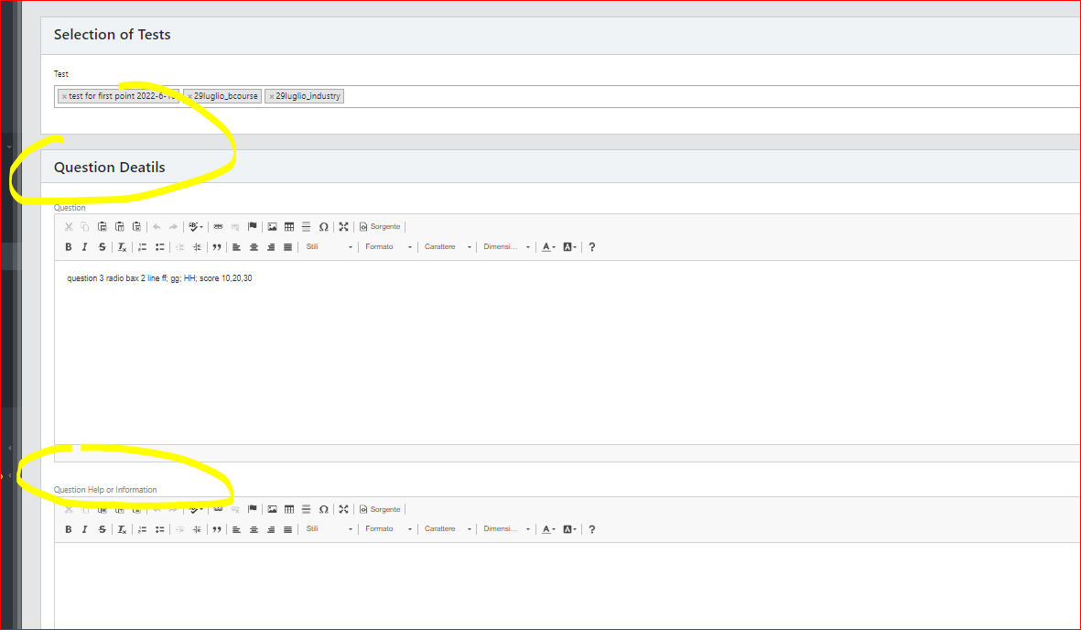

The answer box don’t have that options. So it s necessry solve.

Regard the colors, now some type of answer have the option of colors (for example star and rating. Also for these it is necessary have how default the colors of test Options

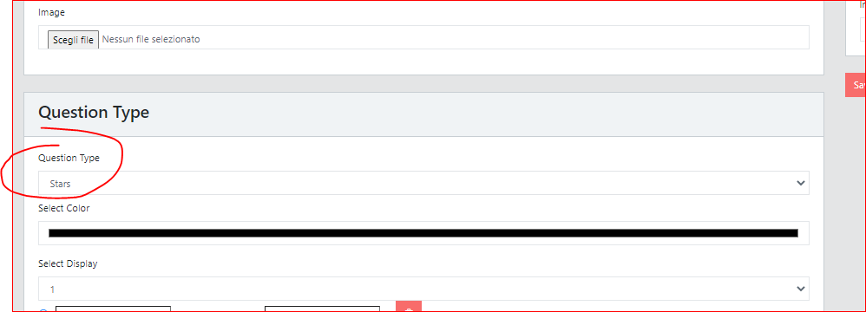

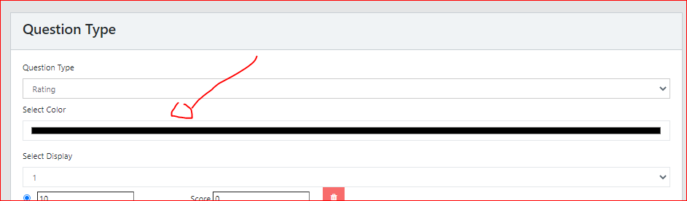

The matrix, range, check box answer don’t have the selection of colors. Infact matrix is only green, the range only ble

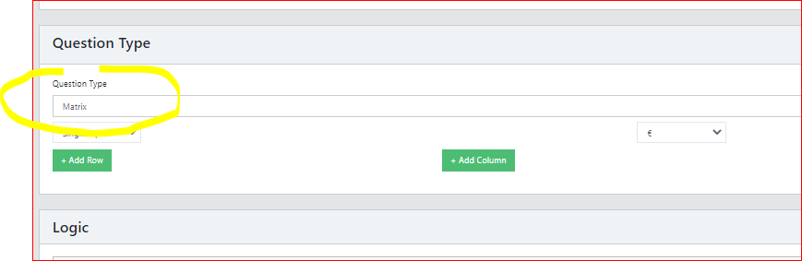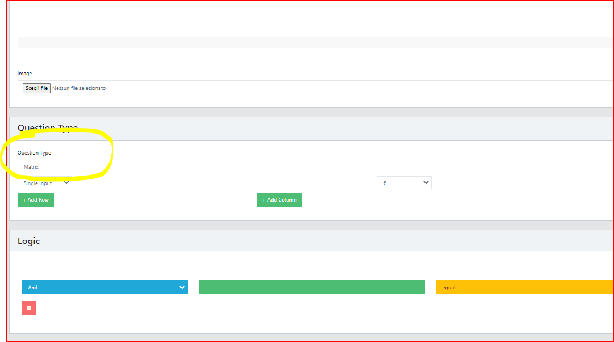

**1.2 Question area (the position of images)**

Now there is a material divison between description of question and answer. So create 2 problems (the images and the positions. Pratically it isn’t impossible create a personalizzations of design (positions of description of question, position of answer and images).

for example it is impossible create the following design (image to the left an description of question and answer on the right)

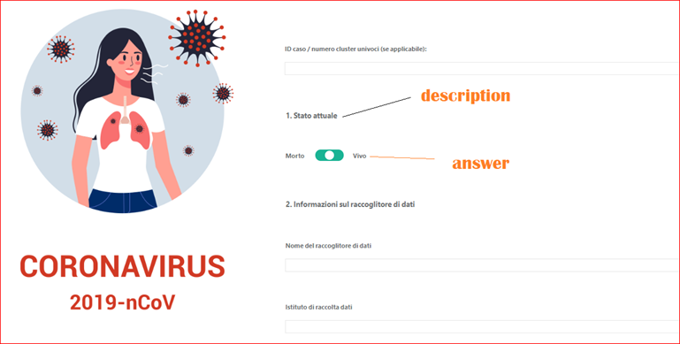

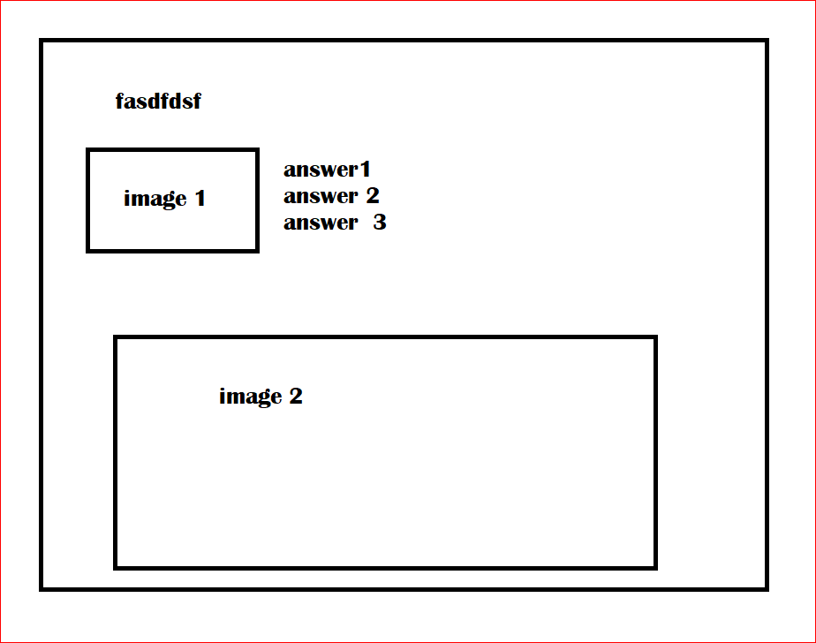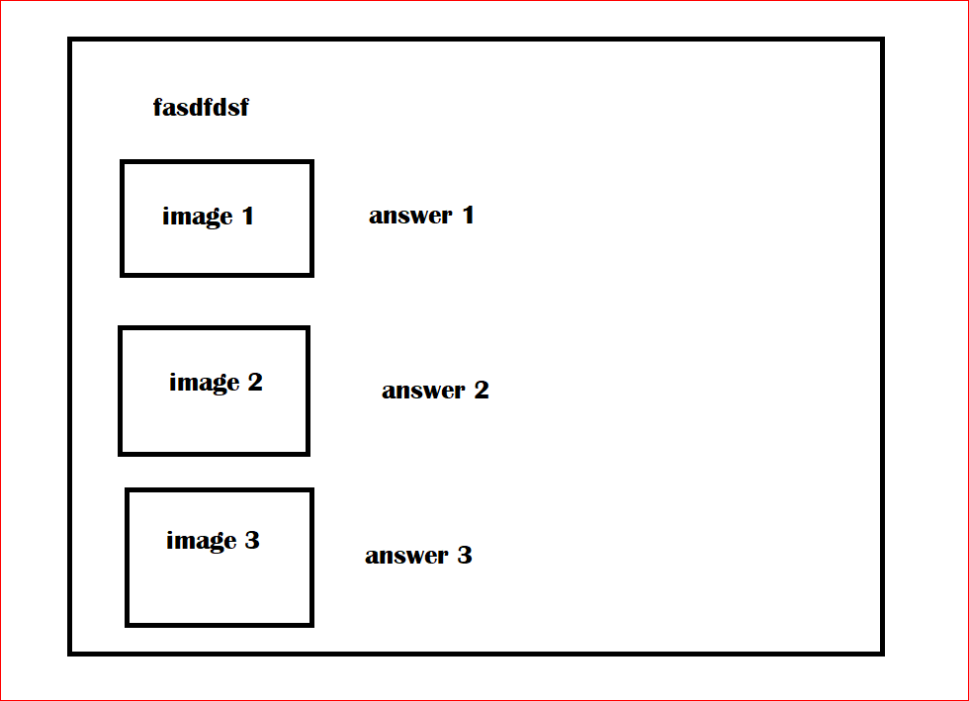



Also the position now is a problem, see the folowing image. the formattation is orrible,

to do this formatting now it is possible using some otpion on the right, but isn’t good. And use the add image down, but have 1 image and it is not possible delate. i want more image and the administrator must decide the position how showed before

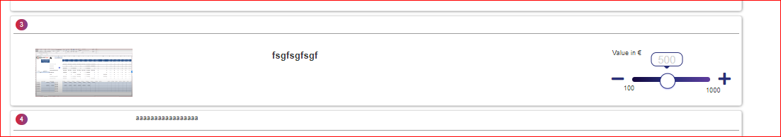

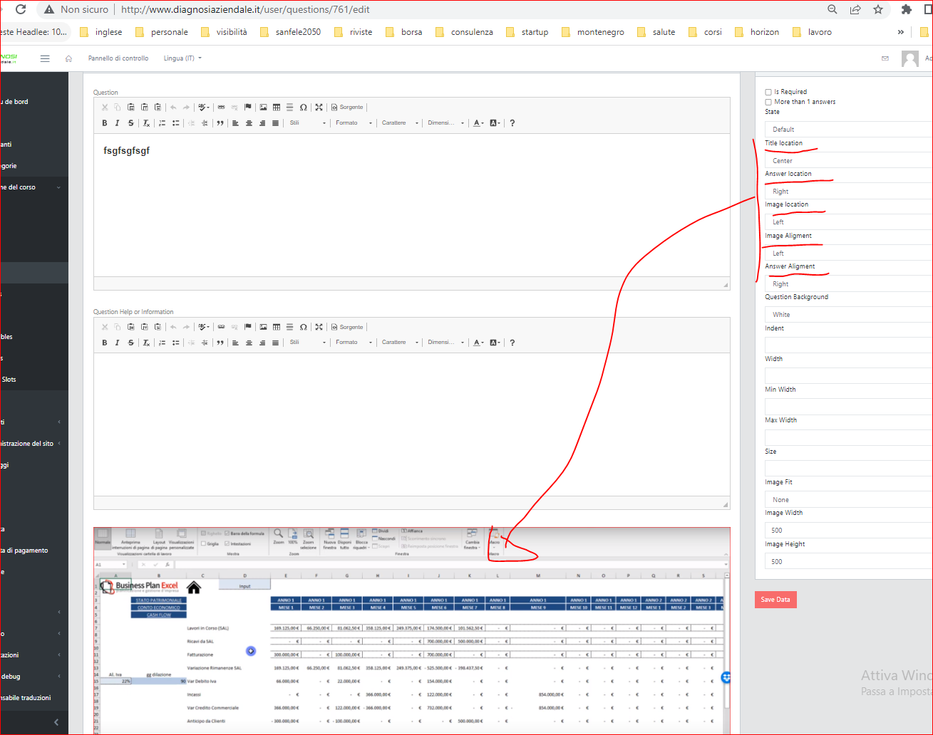

1.3 Veryfy if work add in “file” type the options of “type of file” and “size of files” that the software must acept (mb). These options must be saved in the database and must work in user when the the user add the files. So when the user add files, the software must acept only the type of files (one or more) and sizes decided by admin in admin page “questions”. the software must show a a popup that comunicate that it isn’t possible add that files. it is neecssary add the principal type of file so: doc; txt; word pad; xls;mbd, power point; pdf; ql; zip; rar; jpg; png; gif; zip, rar, …….and others

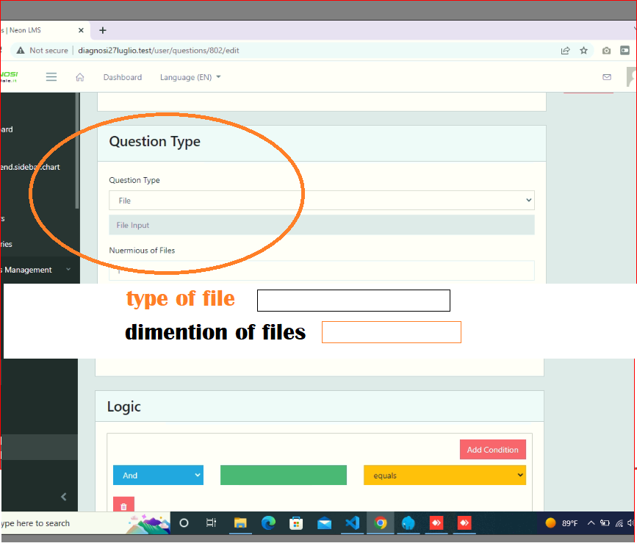

**This is the user page, question to add file.**

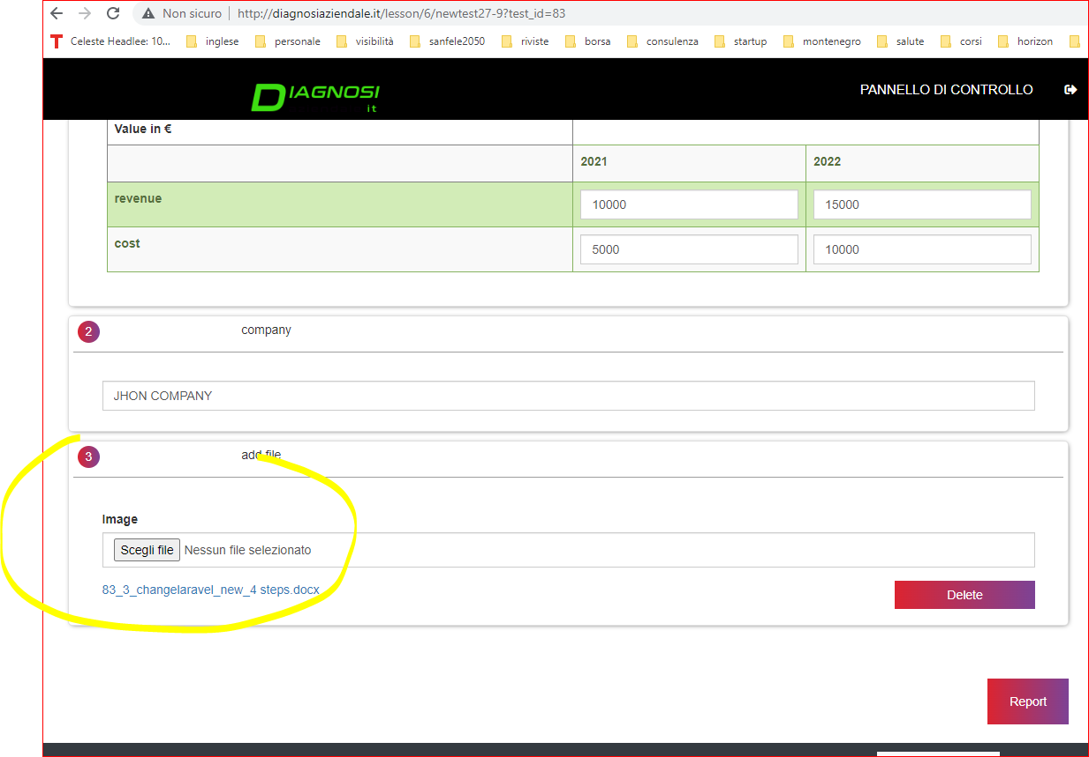

1.4 It is also necessary that the administrator can see the file add by users. So for example the user regard 3 questions “file” add some files. Now in page “order” there is button with the downlaos, but don’t work.

It is necessary that in order page the software show the list of questions with the files and the list of files add by users to do the downlaod (make how the following image).

If the user didn’t add file the software don’t show the button download (nw show always).

By first images you see how now th user add files and in the secodn images you see how i want see that files add.

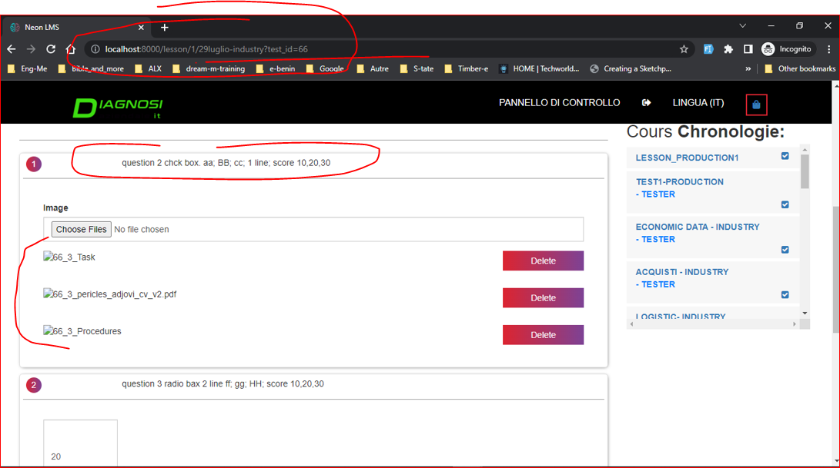

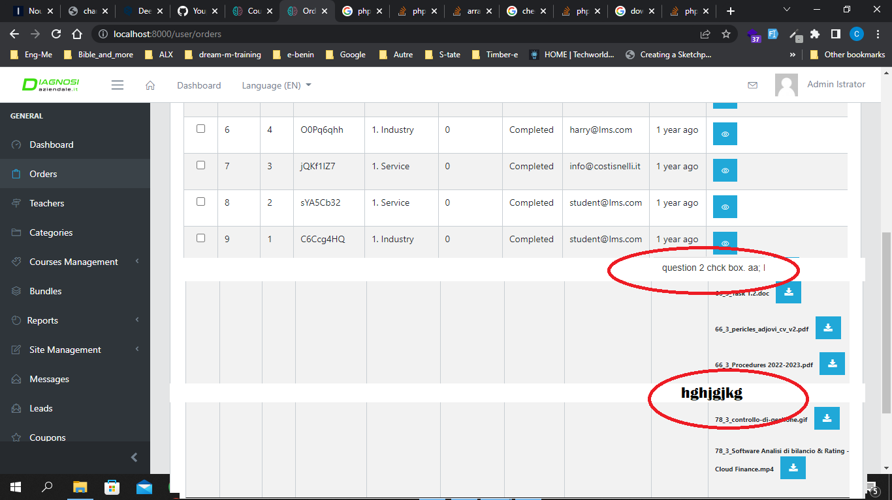

1.5 Answers type “single” input and “value in euro”. In admin, type of questioni it is necessary add the impostation of dimention of box (width). In this way the admin can change the width and hight of box to input. Yhese change must be visible in user. the options mut be saved in the database ad changiable by edit page od admin. By image see how is now in admin page and how must be after.

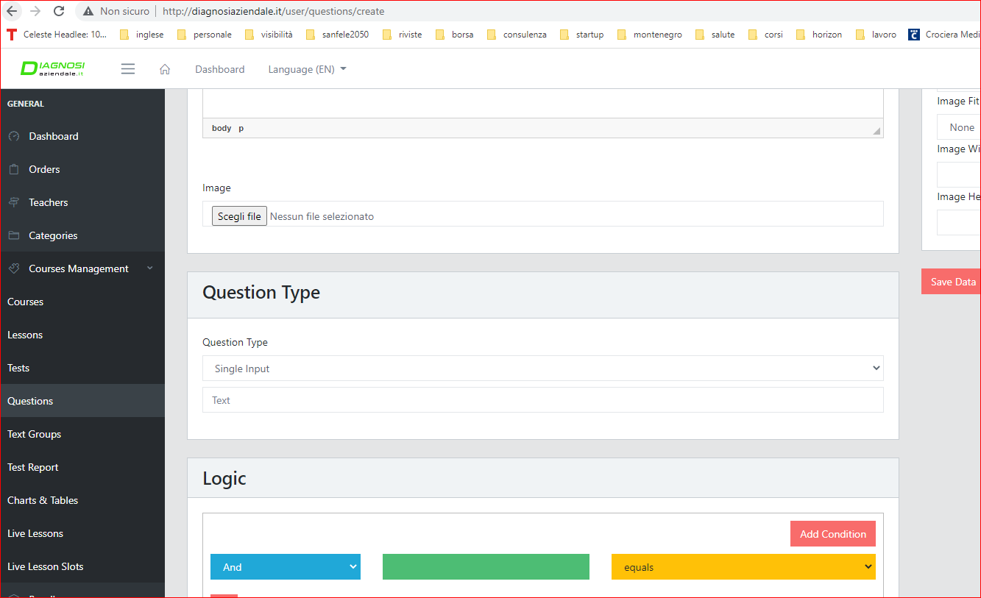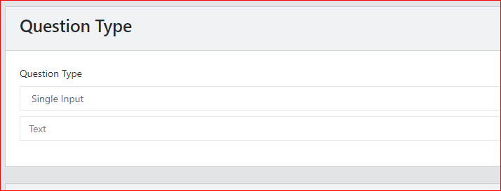

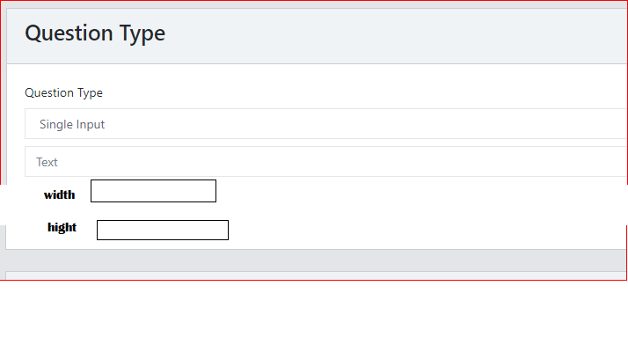

I show the problem that have now the page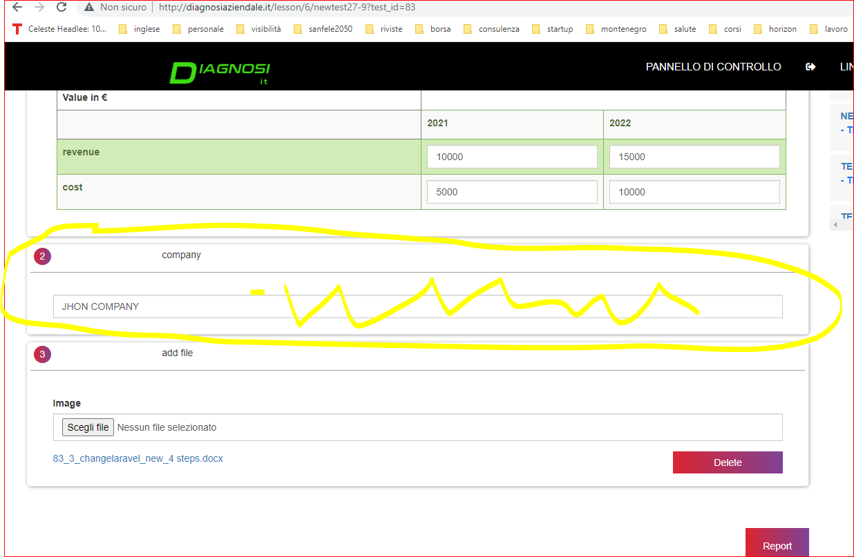

**How i want**

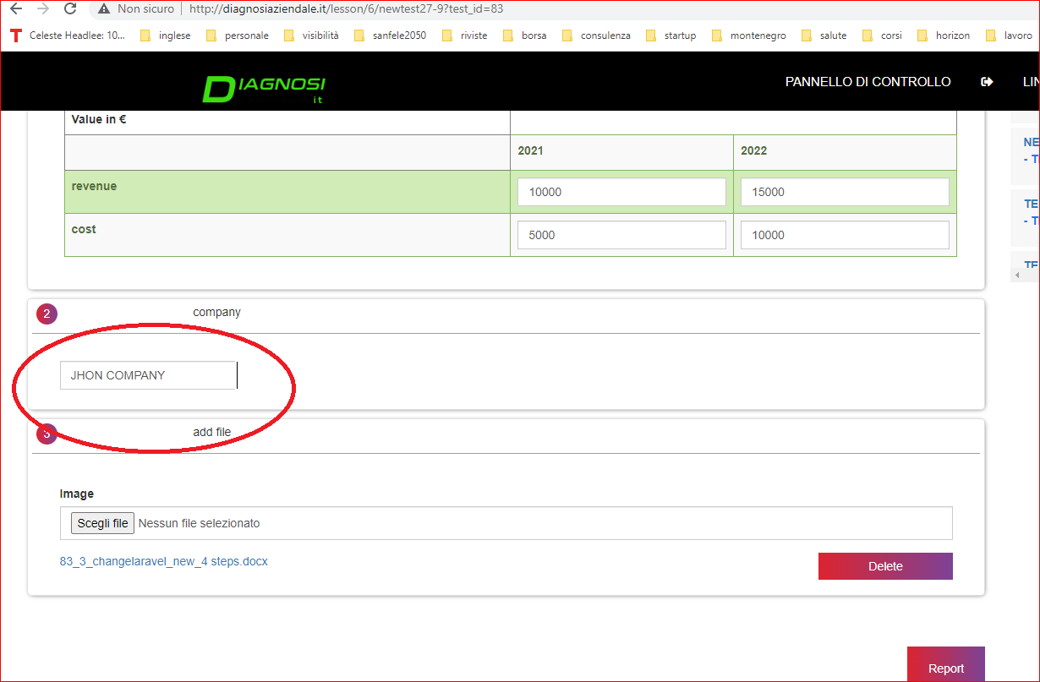

1.6 Other changes

- Table of question. Now also the table don’t have a defualt color, buti t is green. Also for these it is necssary use the default color,dimention and alignment and add in “type of question” of question page the options to chnage them. So it is make a better Finally it is necessary delaite the text

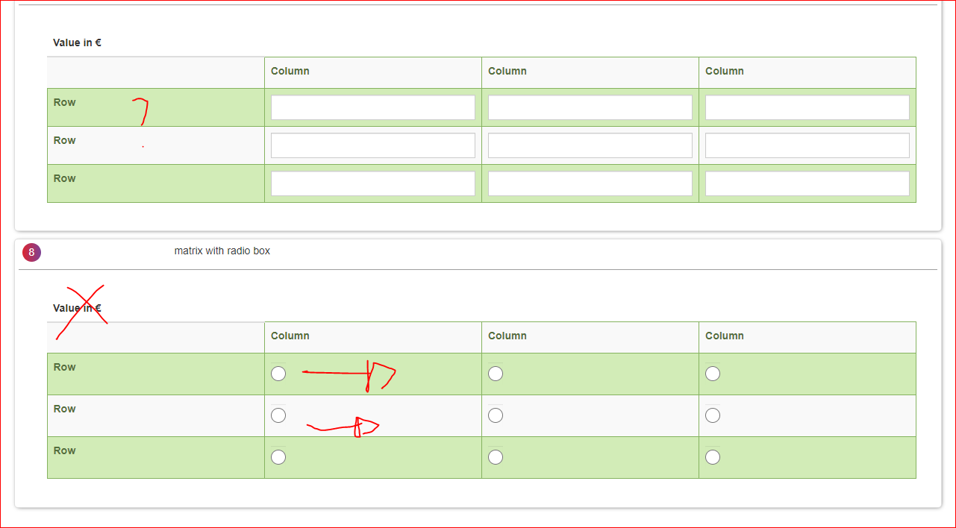

So pratically it is possible have in all question (on the right) the color, dimention, how defualt regard all questions and in the specific questioni it is possible change. already many question have this (for exampel color of rating, but aren’t connection.

- make a button of checkbox different by button of template, and must have many different color regard seelcted, not selcted. now the difference is minimal

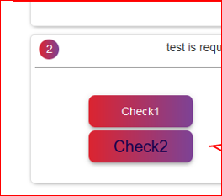

- value in €. regard value in € question, range and table with value in € it is necessray that the software use the “.” and the decimal automatically how i show yesterday, so for example 10.000,00 (not 10000)

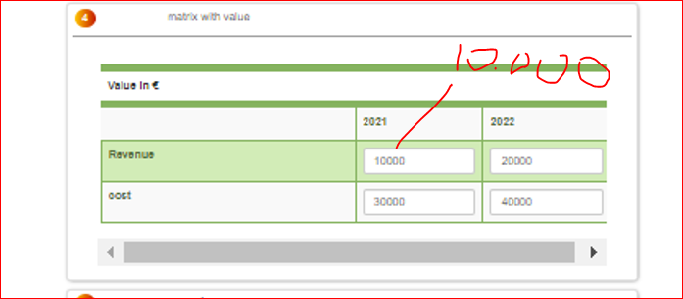

all value of web must have the € logic, so (10.000,00), so point and decimal 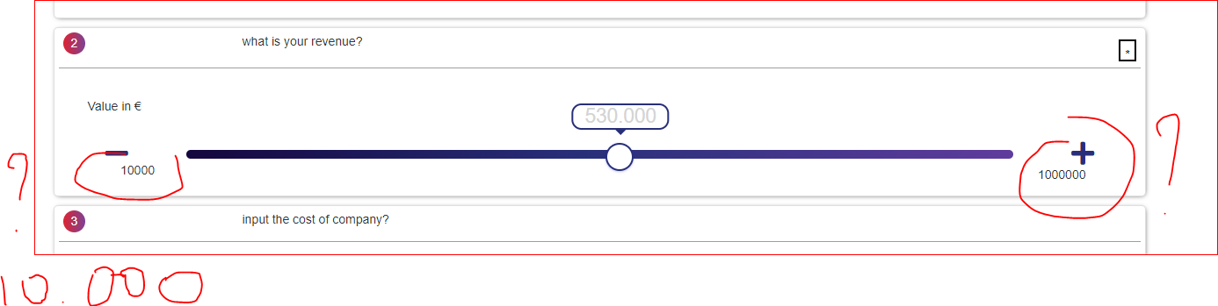

**2. Solve some errors to creation charts**

* 1. In user page – report the software don’t show the charts.

Aftet answer the questions the user click report and the softwate show an automtic report based on some quuery (the report use short code).

* 1. change the type of chart “not chart and table”

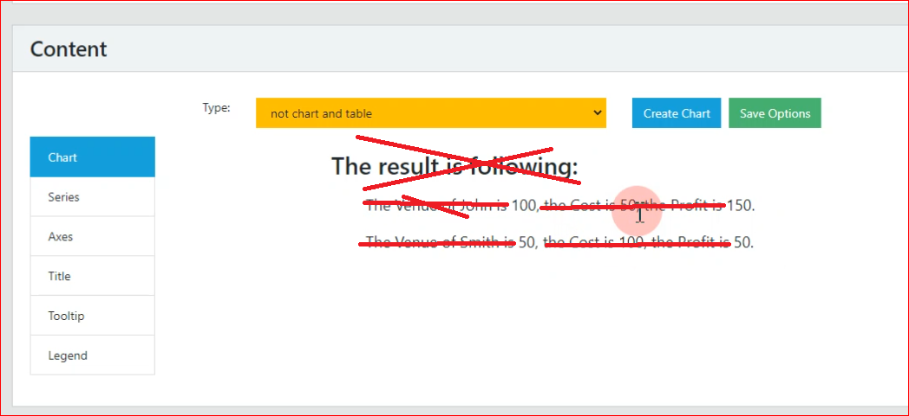

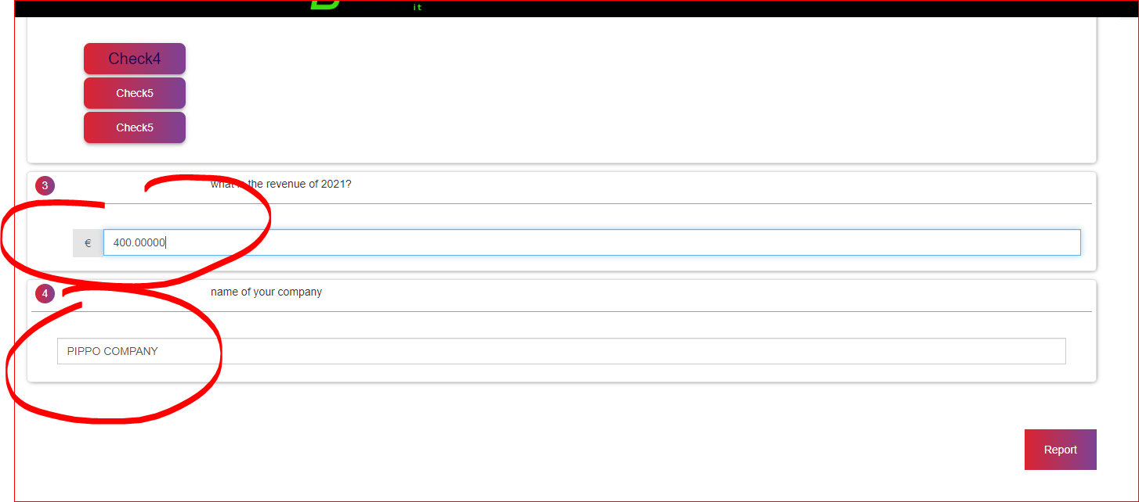

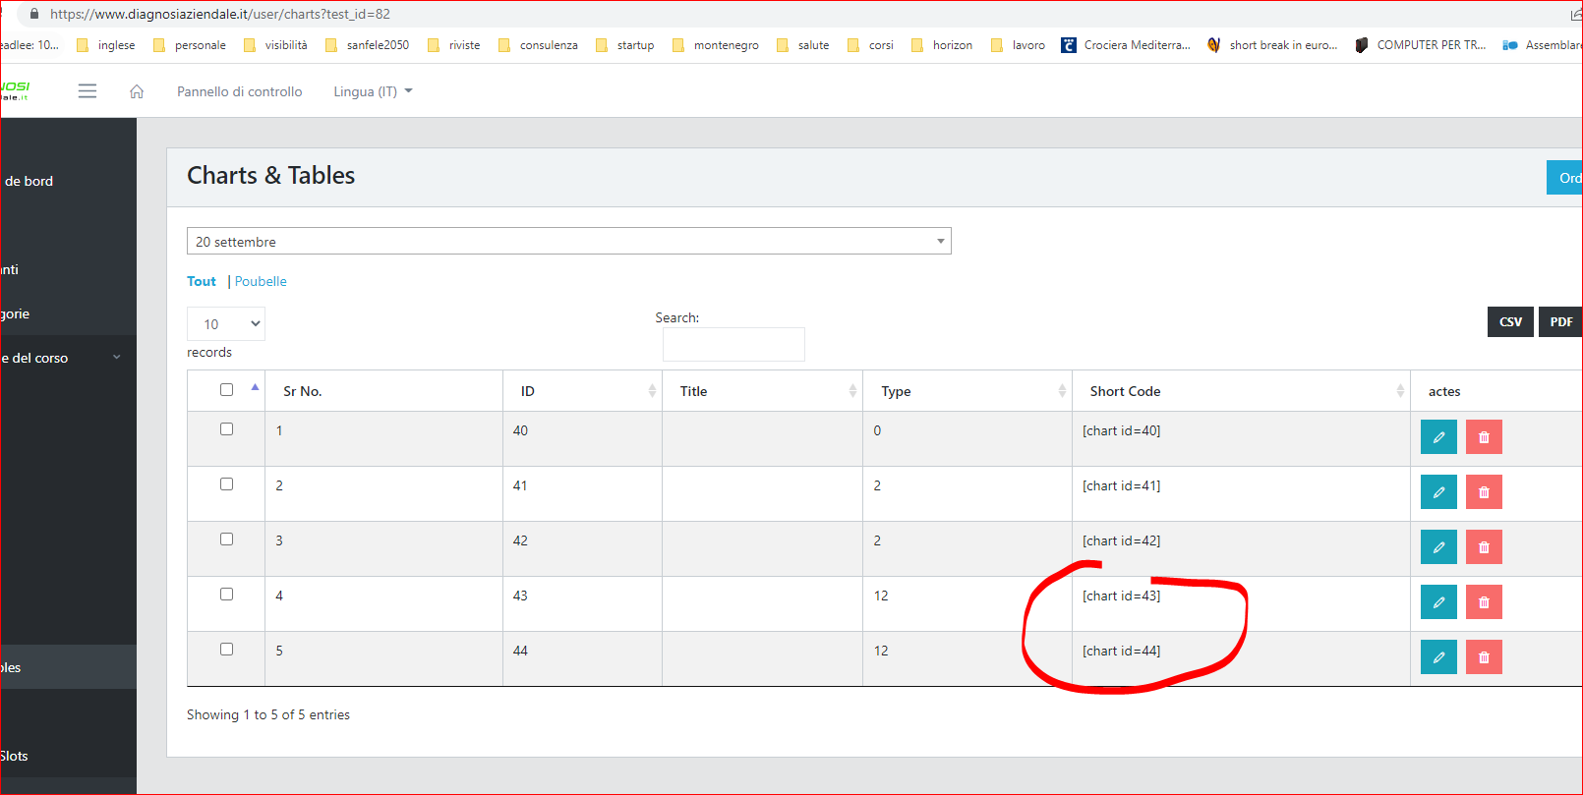

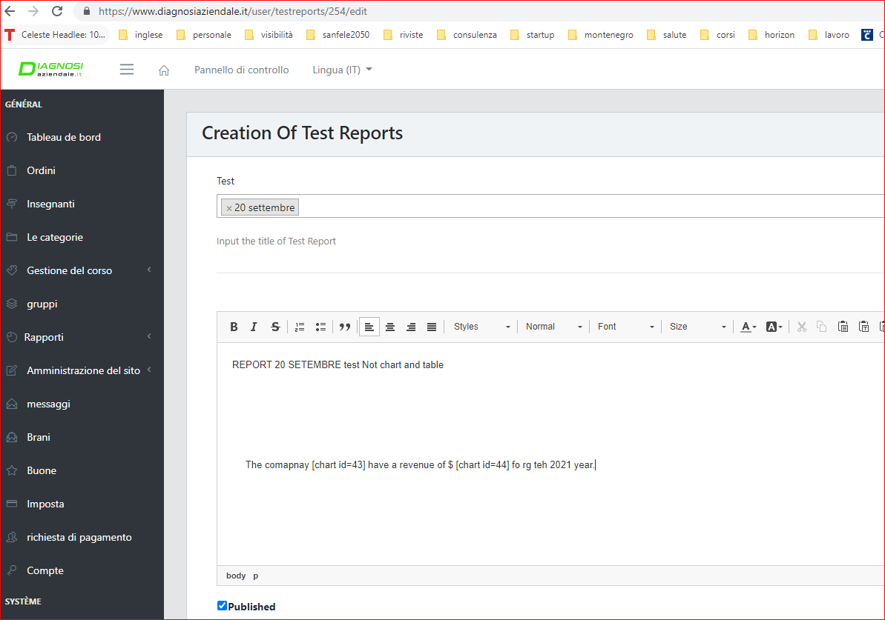

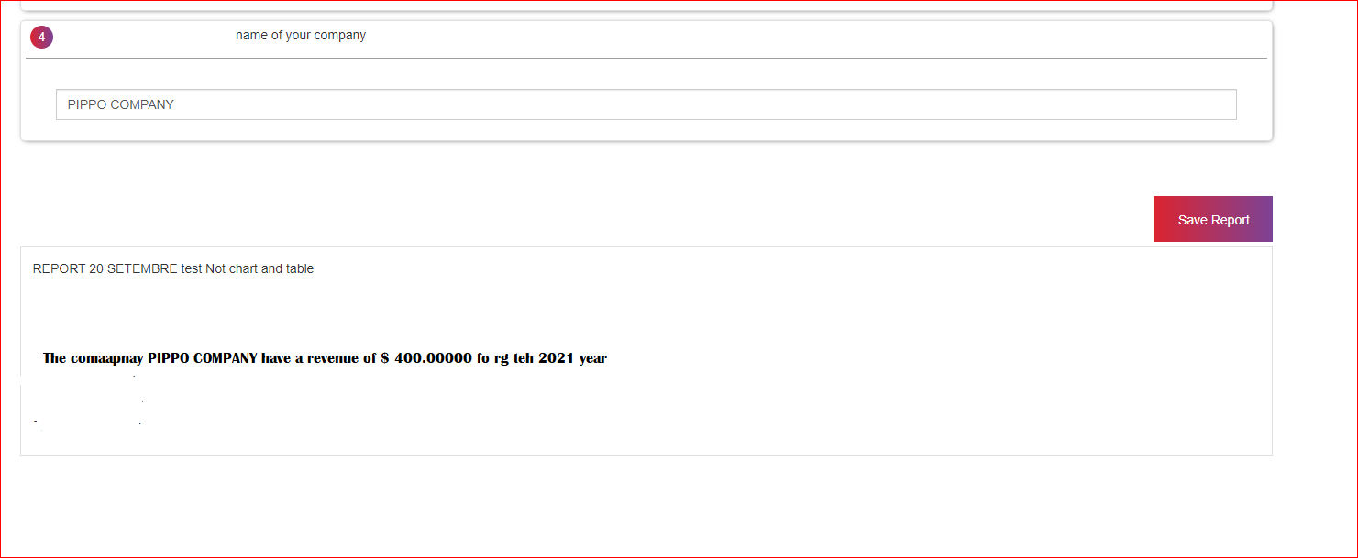

* 1. the software must show the charts optioin in creations chart &table pages
  2. it is necessray verify all options of charts, so the color of bars of all charts because now don’t work well

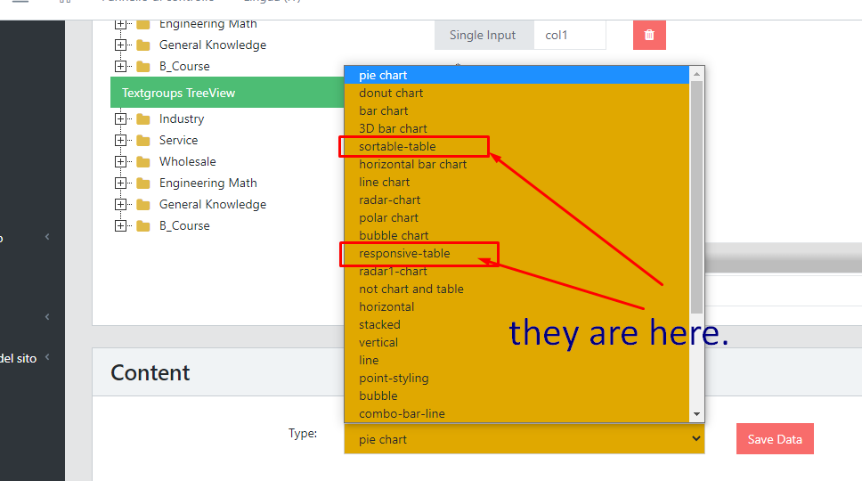



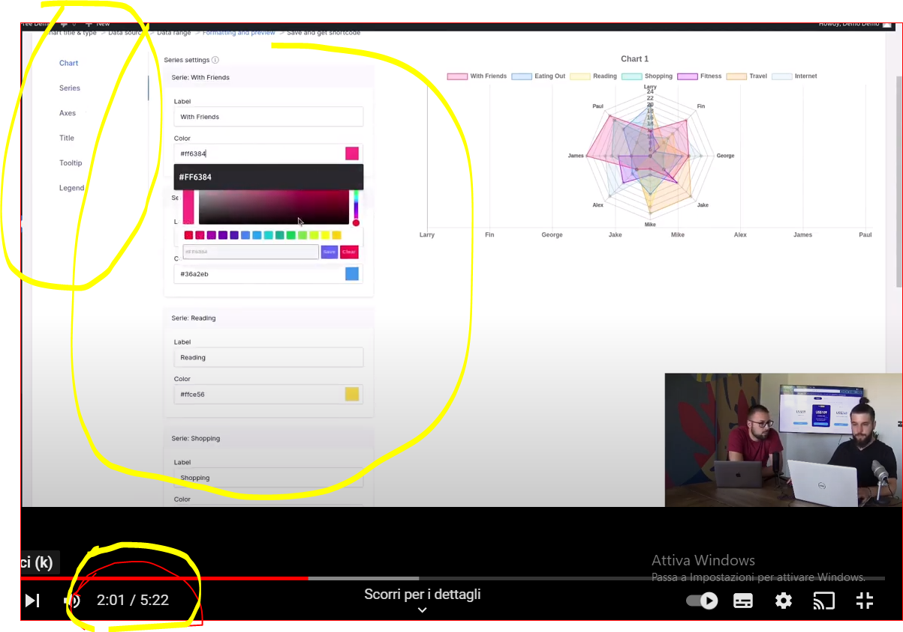

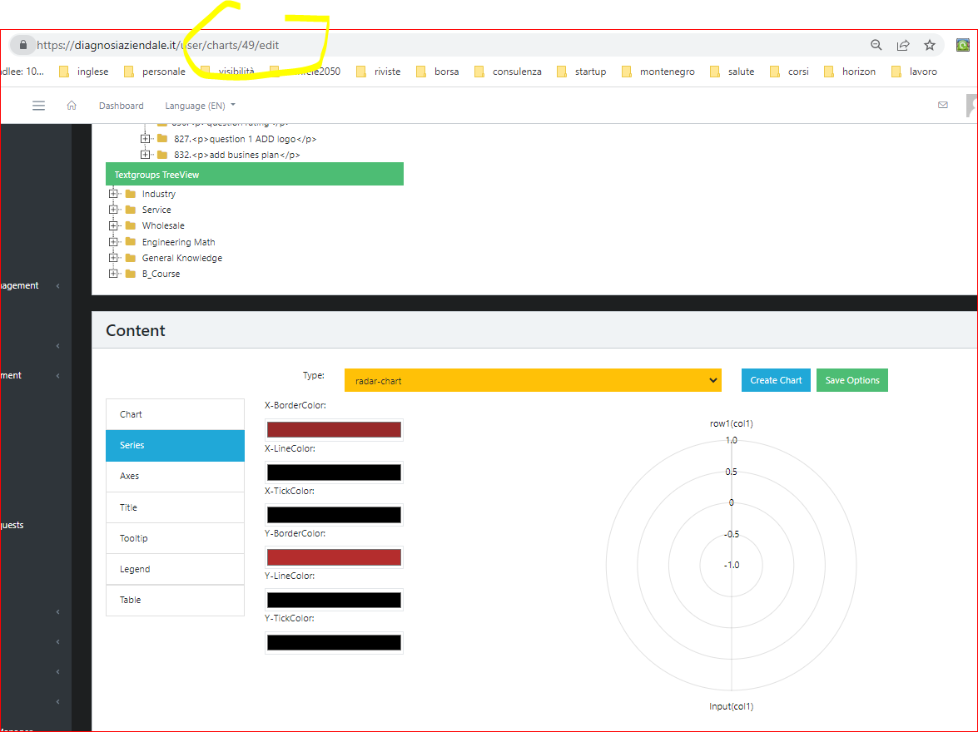

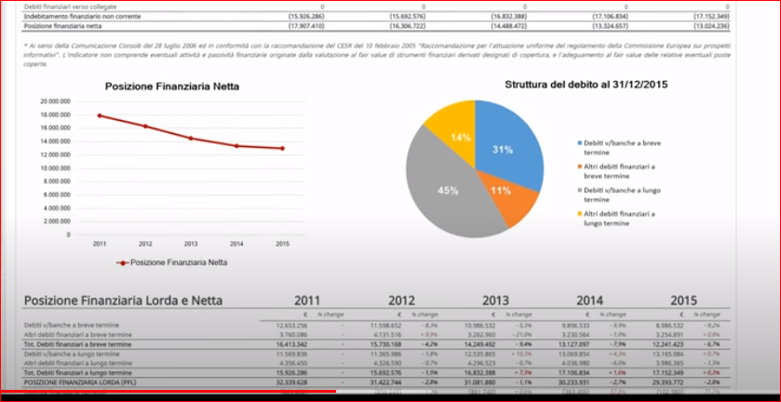

**3.Other Features**

**3.1 Order of course – orderof test and lesson: now by list regard the question pages (in admin) it is possible change the order of question. You can see how work in question. It is necessary add this feautures also in course list, test list and lesson list.**

**Pratically how you see by images now with mouse it is possible change the order of questions. It is necessary copy the same features also for courses, tests and lessons. Make the enlargement of the following pictures to understand. the changes must be visible in user page.**

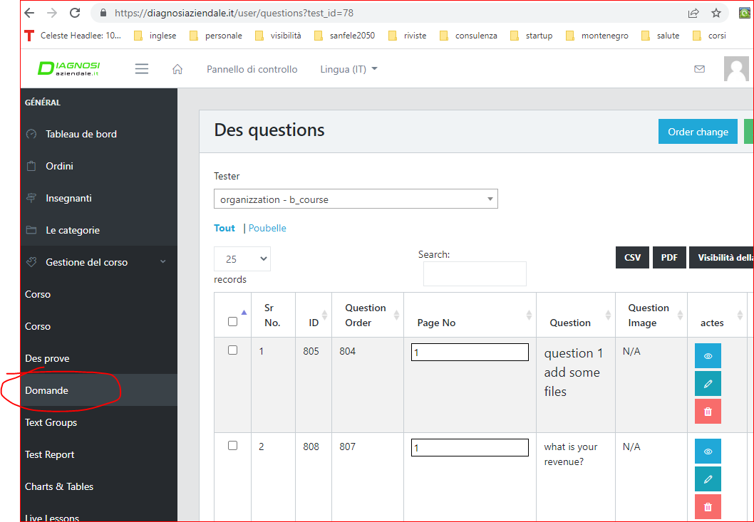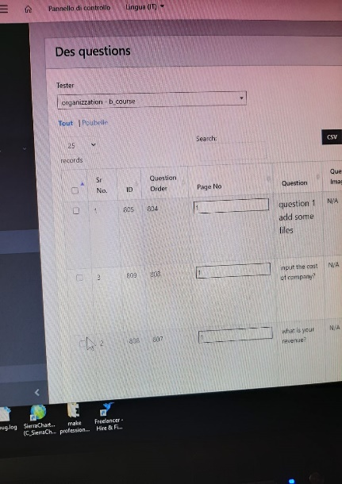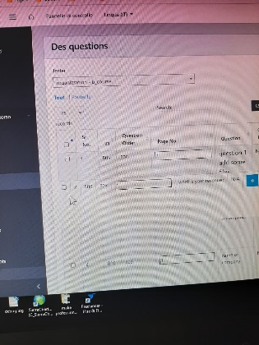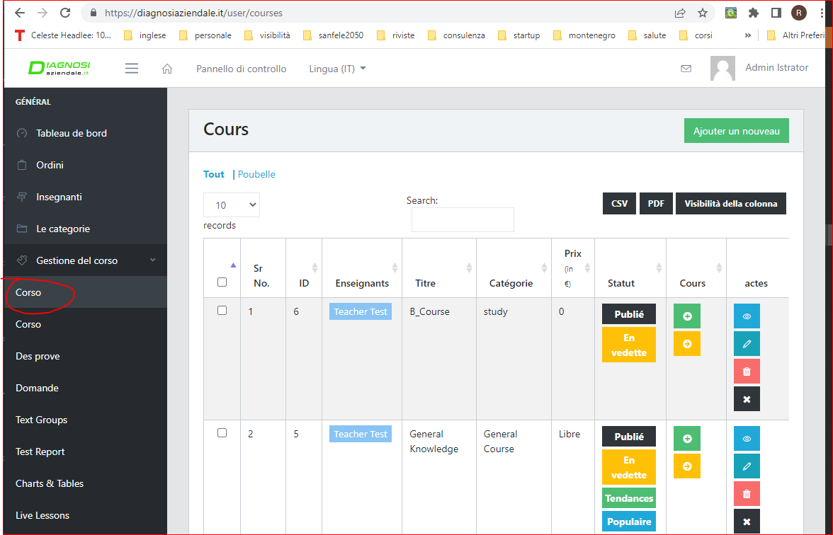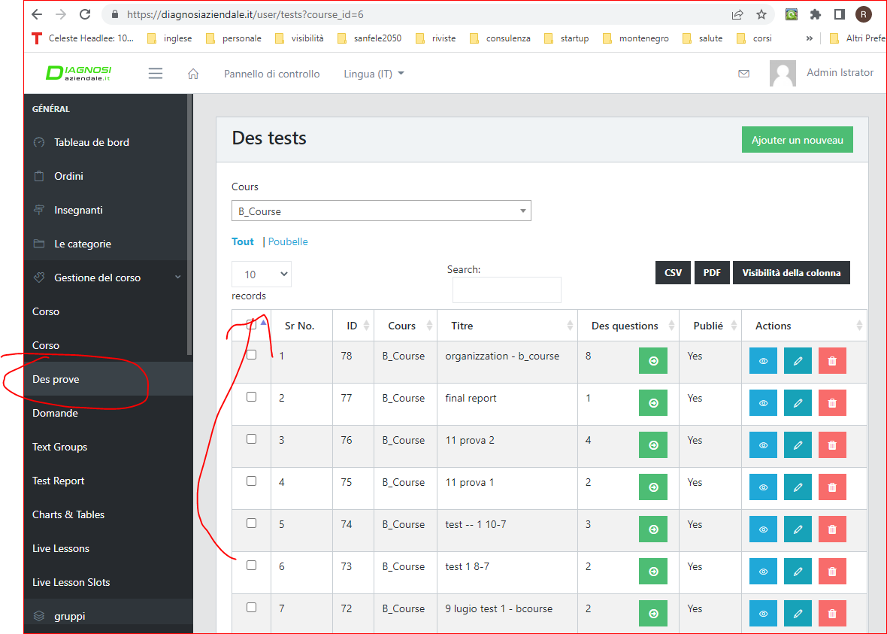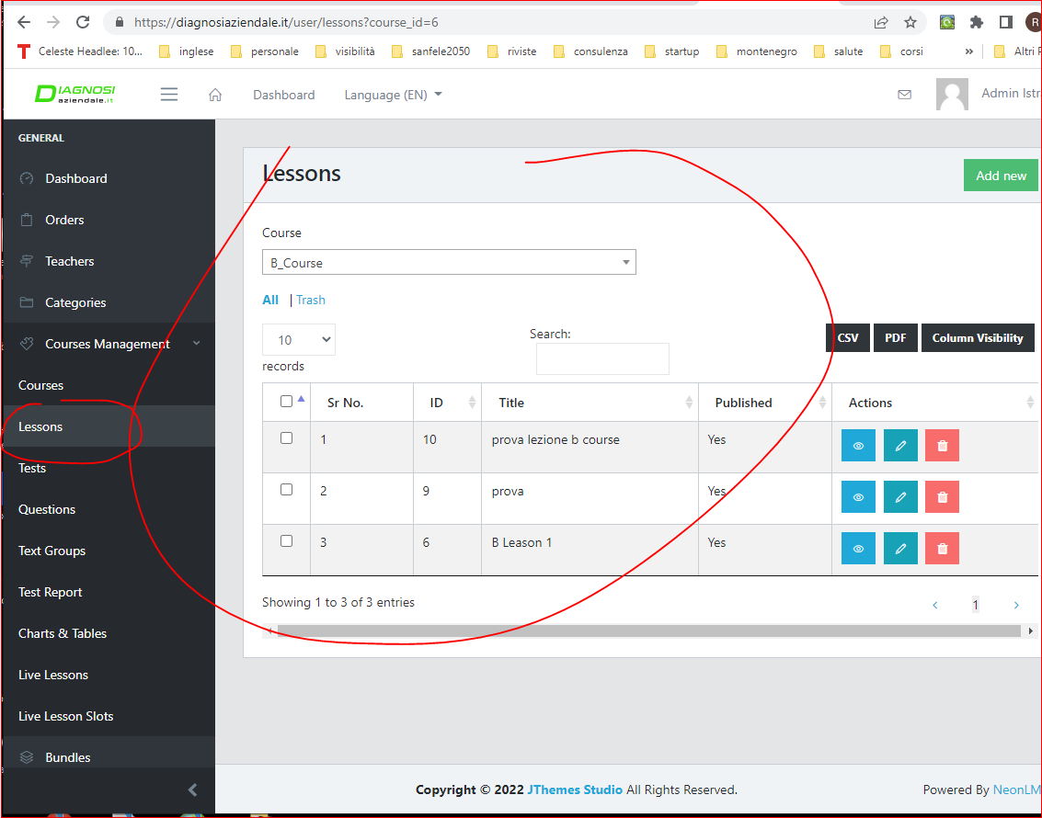

**3.2 report: the software elaborate a report when the user click report. It is necessary that the software create also a pdf file and save it in the user dashboard. The administartor can decide to send to email of user of the pdf report, so it is necessar y verify this option.**

**Example of actual report on web page and how must be the user dashboard**

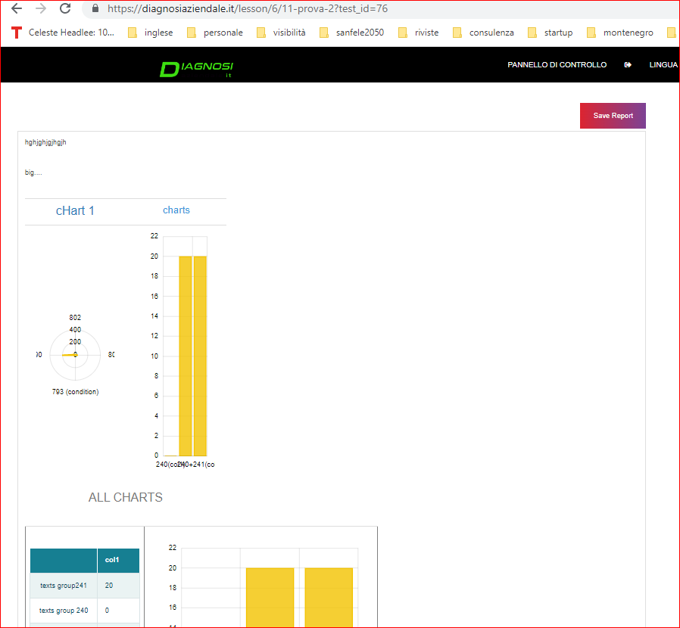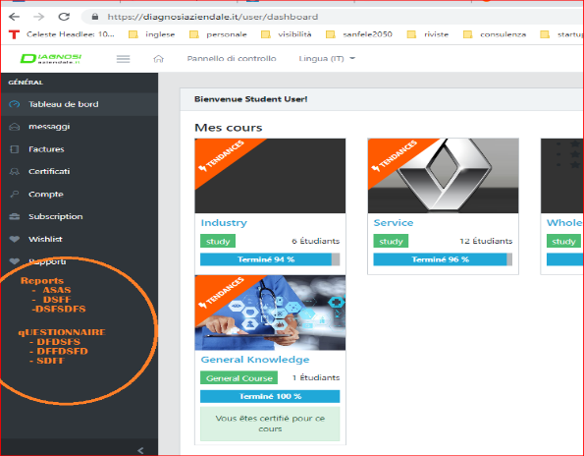

**Finally the software must also save in pdf the test with answers and show in user dashboard**

**3.3 time of change of report and defintely report. Now it is possible change the answers, but it is necessary create something to block to user the change of questions. We can put a time and option report in drafts. In this way when the user click definitive report or the time is finished he can’t change the answers.**

* 1. **the administrator must see the answer by admin page of user and must change alway the answer. So it is necessary add a link in order page (admin) where the administartor can open the questionnaire with answer.**

**4.5 add other type of matrix. It is necesary ad a new type of matrix. it must have a tree table how see in the image and video.** [**https://youtu.be/qSD5NqD9bFk**](https://youtu.be/qSD5NqD9bFk)

[**https://www.jqueryscript.net/blog/best-tree-table.html**](https://www.jqueryscript.net/blog/best-tree-table.html)

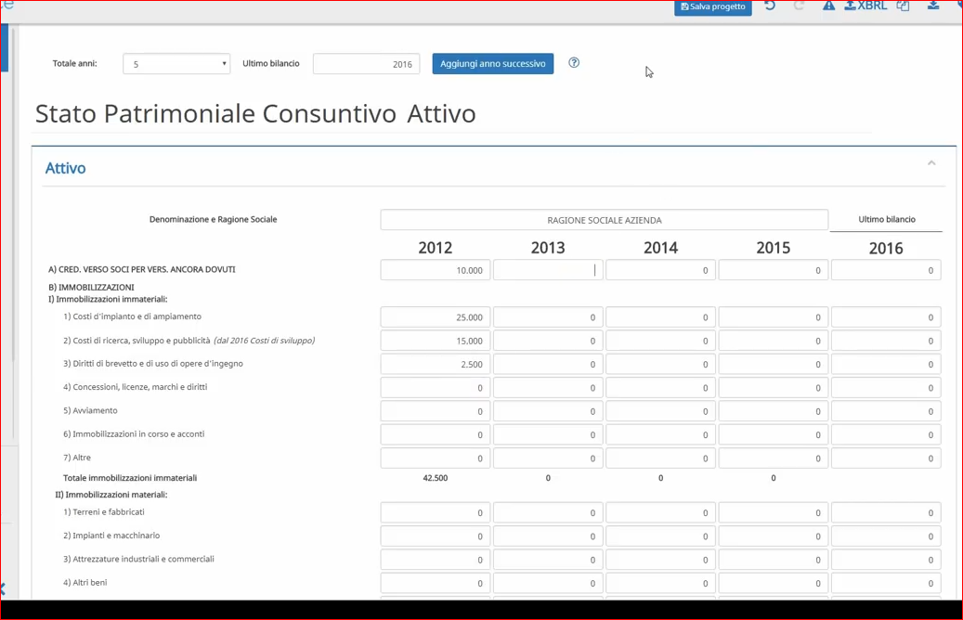

**3.5 test group. One text must be showed in report regard a textgroup. Now if the administrator don’t make perfectly the selection show all tet alternative. it is necessary that the software show only one text. it is a banal problem but i can explain you by anydesk meeting**

**After solved these list it is necessary make a meeting together to test al software and see if there are other erros that now it is impossible see or explain all.**

1. **Small Changes**

Many small changes: the web have some informations that I don’t want so it is necessary hide them in user pages. Do to this we can make a test by anydesk and verify. They are small changes. These changes regard also some link to go fast in the correct page, add or elimnate buttons.

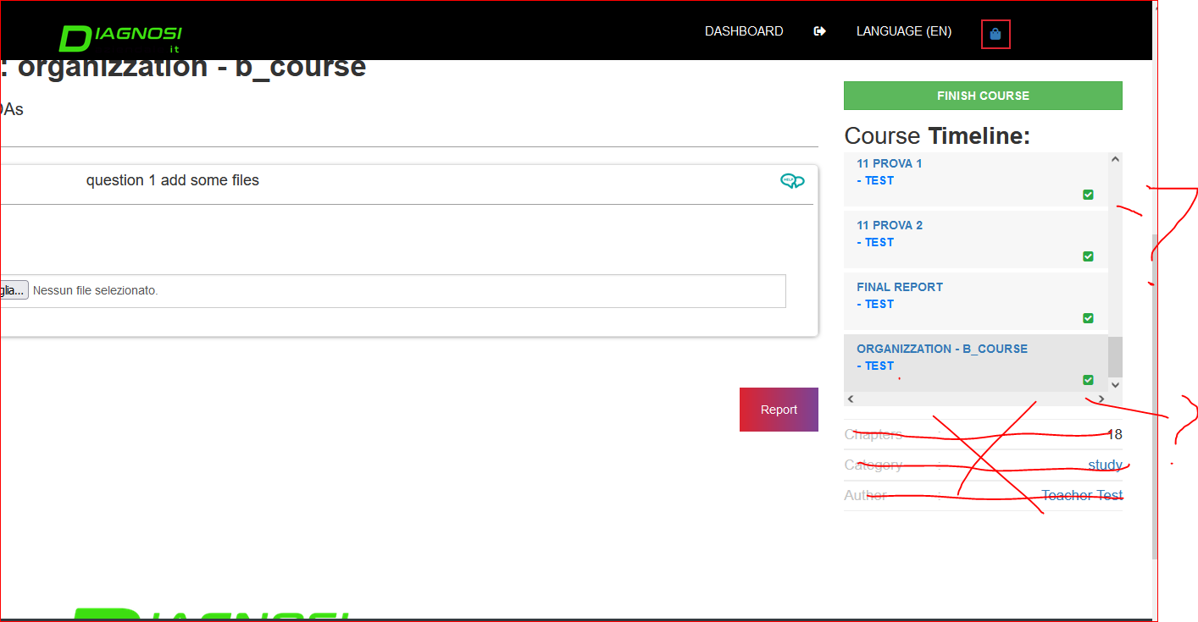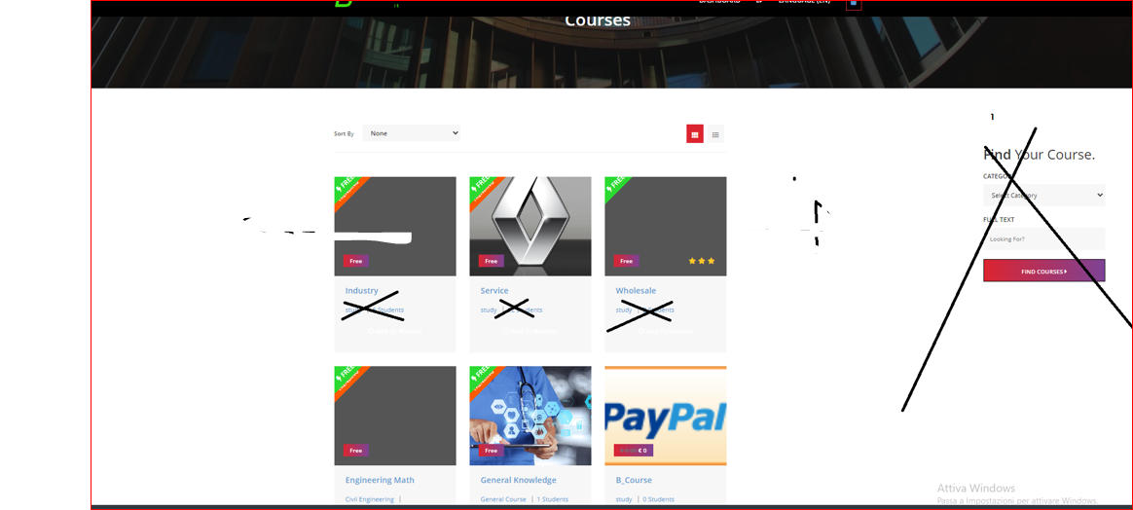

4.1. delate the popup (controll password) in home wehen open the web. It is necessary solve it not by chrome but by software impostations.

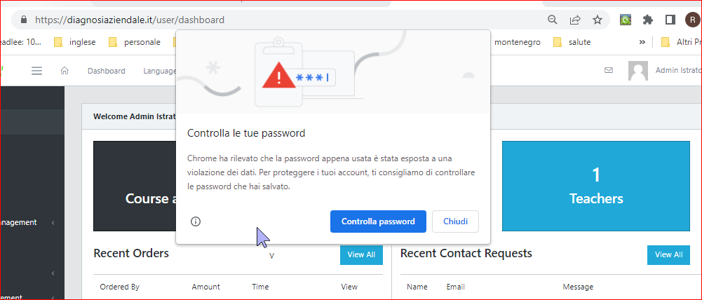

4.2. Italian language.. it is necessary add italian language. Now there are problems because teh software don’t change all, but only some word and link. So it is necessary verify the reason and chnage all web in italian. I attach an example but there are many text in english

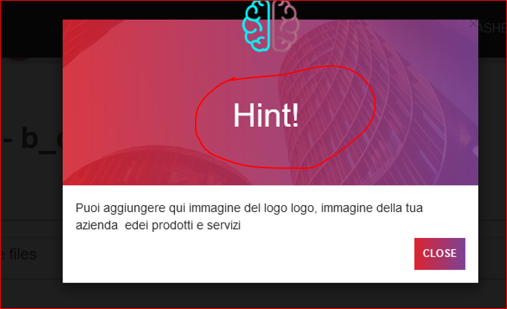

4.3. to use a unique design for all pop up (how help). many of popup alreday are ok, other not. Example for download and

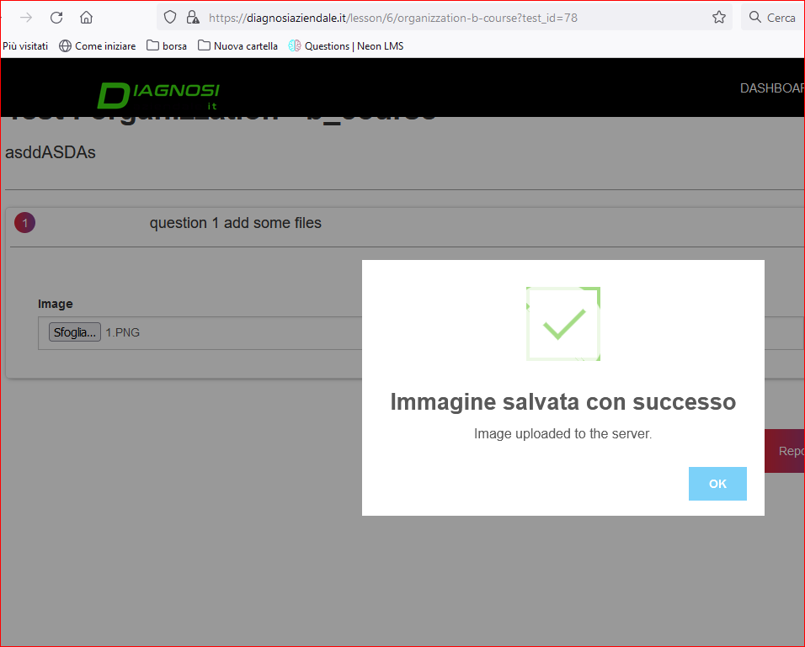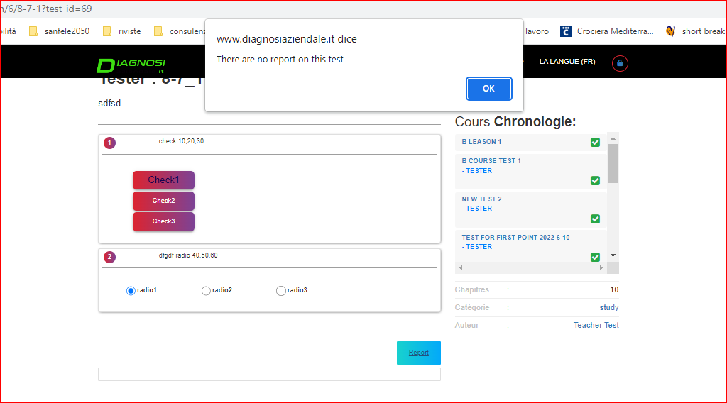

you can use this popup of template.

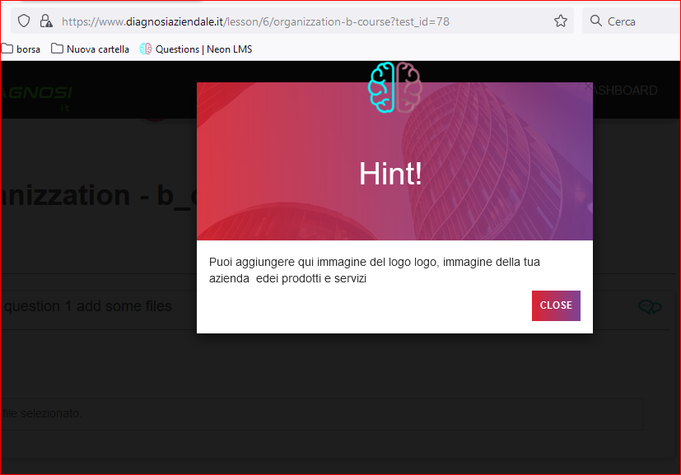

* 1. bord of table in report page and position of texts. Now in creation report page the option table (see image) don’t have al option thaat worlk, pratically igf the administrator put the impostation of bord “no bord” the software show the bord how the image. Now when there is an image th e software don’t make the correct position of text. by image see tha tth eadministartor put central alignment down the image but the software show the text near the image.

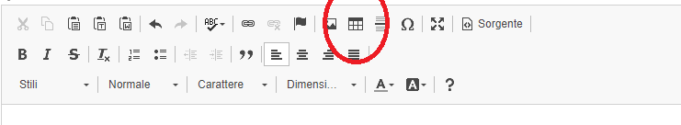

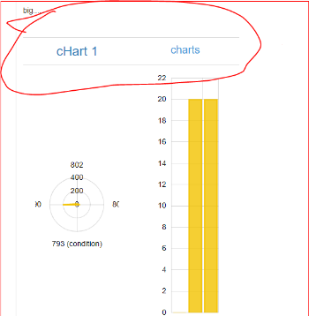 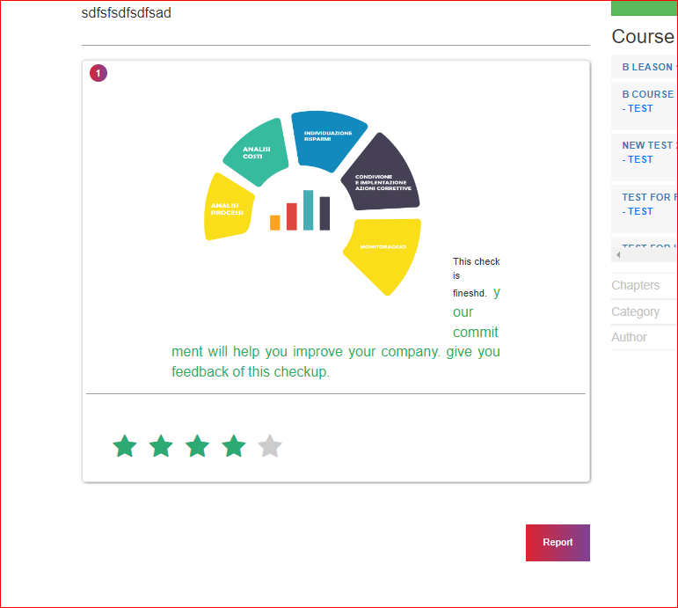

4.5. bar % completations. Now don’t work correctly. it is necessary that the software update immediatelly the % and not after close the questionnaire.

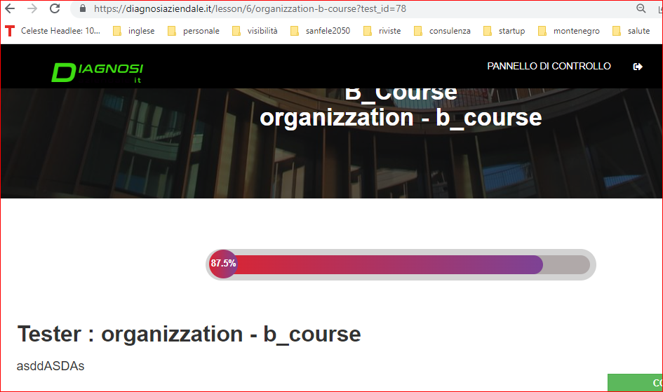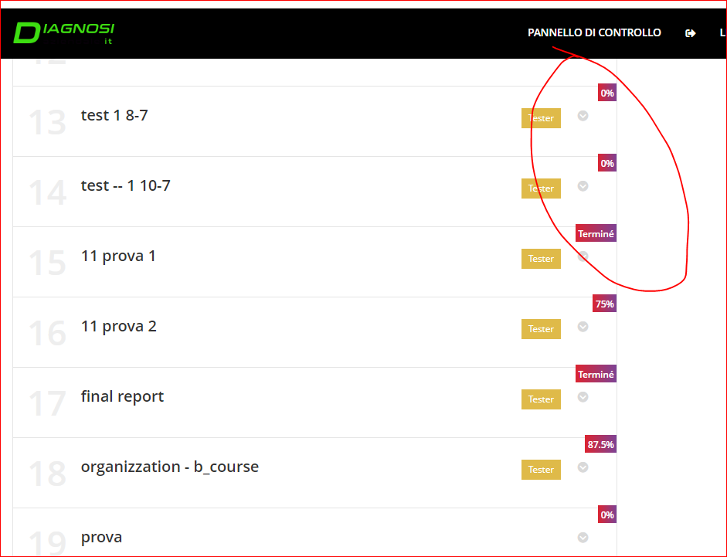

4.6. in page question of admin it is necessary add an identical box to actual help (you can duplicate). it must have also the 2 option identical to actaul help, but when is selected hide it show the text on the right (in the user page. see the following image) The default option must be hide. Regard the actual help the default option must be hide.

it is necessary also verify if the help in creation questions acept the short code. the goal is have also chart on the right immadiatelly.

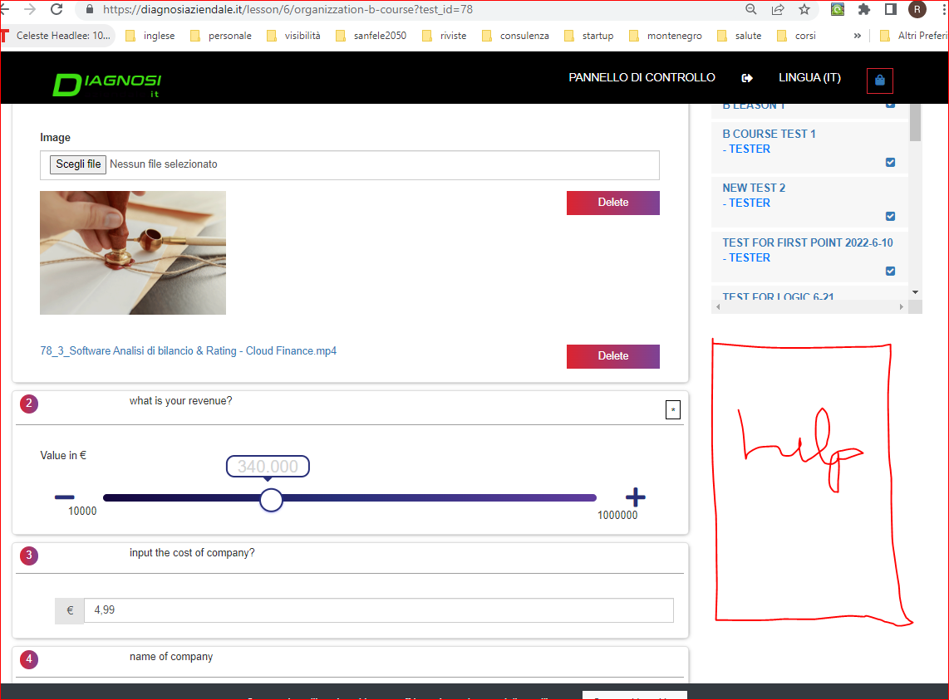

4.7 small change in question page (admin)

- in the question page (admin) there are some type of answers with the option to change the colors. It is necessary change the actual default color with the default color of template of questions (to understand when work I can show).

- For number of questions it is necessary use the default color (default colro on the right);

- regard the default dimention on the right now don’t work the dimention. it is necessary solve.

- regard the option “is request” (see option on the right) it is necessary invert this option. so when isn’t clicked teh questions are obbligatory

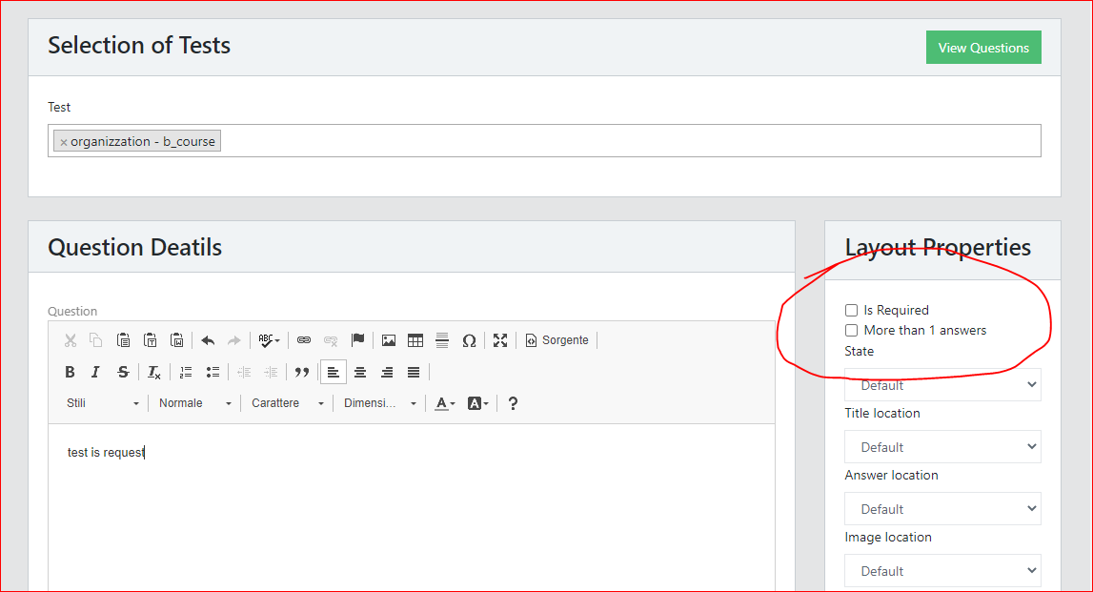

**5. Design changes**

It is necessary make a better design of user pages. I attach some examples. Pratically it is necessary use the same colors of template, adapt the dimentions, identical bottons, change some links because now thee are some errors to go fast in the correct pages (for example to se ethe cours eby user or enought login). So you must verify all user pages and adapt perfectly do have a excellent design, using template and questions options and change it. So it attach also some example, but it is necessary verify all and change because there are many errors to change. Must be perfect in all how these example: <https://www.facile.it/> [https://www.facile.it/assicurazioni-auto/preventivo.html www.cloudfinance.it](https://www.facile.it/assicurazioni-auto/preventivo.html%20%20www.cloudfinance.it)

<https://www.webank.it/webankpub/wbresp/calcolatore_mutuo.do?gclid=Cj0KCQjw1bqZBhDXARIsANTjCPJUCVMf2hC9z1uY9akN4eWbrqDw3E6tSLsLQ7qJ32O7a5bkFT0mp9saAmUvEALw_wcB&gclsrc=aw.ds> (see these web also to undesrtand how solve the feature of point 1).

**I attach two example, but it is necessary make many small changes. we can see by anydesk togheter all the web, so decide in detail the changes and make.**

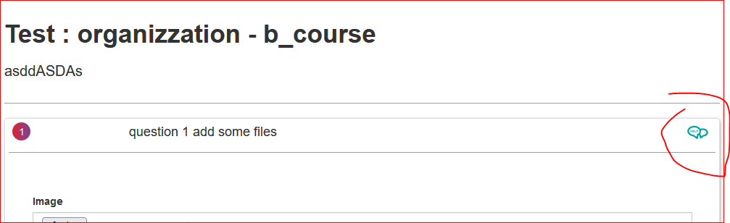

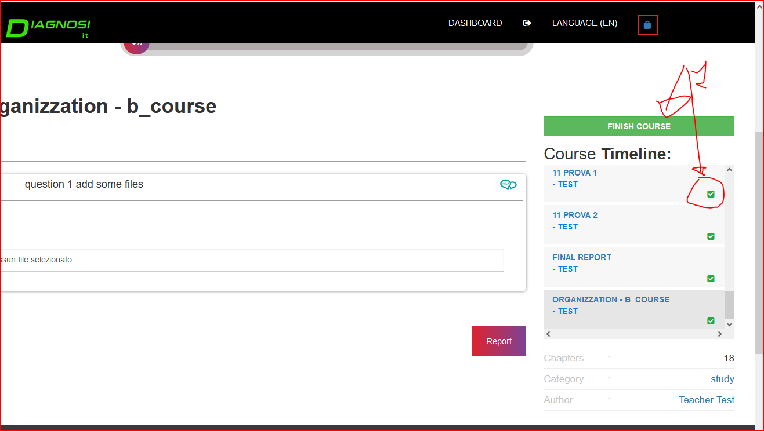

finaly, it is neecessary verify if the software work perfectly responsive. Now the web is already responsive but pheraps some user page don’t work good, so it is necessry berify and solve if there are problems

note: now the design of “*” that means that the answer is obbligatory is bed. It is change it using an icon more beatiful how color and design how templete

**At the end of job it is necessary make a final test, eliminate not necessary file and put the web on my server**

**Very Important conditions:**

1. max budget 200$ (the price is fixed, so it is not possible increase).
2. job deadline: 1 weeks
3. it is necessary verify before all code, all document and all web by login in local because only in this way the developer can value if have the competence to solve the errors. I can send also the code
4. I can award only after demostration that have that the developer have the competence. So it is necessary make a proof (solve the point 1.1 of project). If the proof is ok, I wil award